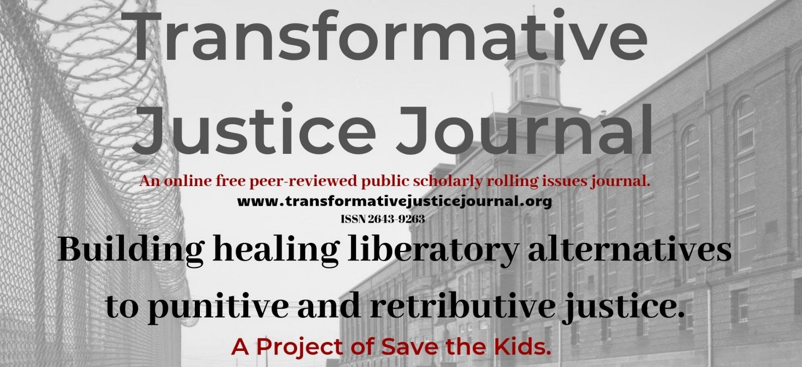

Volume 1, Issue 4, 2019

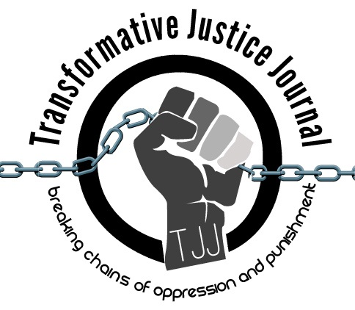

TABLE OF CONTENTS

About Transformative Justice Journal ……………………………………………………………………….. 2

Location ……………………………………………………………………………………………………… 2
Editorial Team …………………………………………………………………………………………… 2 - 3

Submission Guidelines ………………………………………………………………………………… 3 - 5

ARTICLE
On Carceral Feminism, Safety, and Transformative Justice……………………………......…………………………….…6- 11
Lucas Alan Dietsche

ABOUT TRANSFORMATIVE JUSTICE JOURNAL
The Transformative Justice Journal (TJJ), founded in 2012, is an online, open-source, and peer-reviewed journal dedicated to promoting transformative justice. As an academic-activist journal, TJJ was developed out of scholarly and community dialogues around promoting a decolonizing critical criminology social justice punitive/penal justice abolition community-based alternatives to both the retributive, punitive justice and utilitarian punishment models used by criminal justice systems, which victimize offenders and re-victimize survivors of offenses, while promoting profits over people and corporate interests over community interests. The current punitive criminal justice system takes control, responsibility, healing, and accountability away from victims and offenders and instead gives them a powerless and victimizing experience. Transformative justice, a decolonizing and anti-oppression approach, however, views conflict not from the lens of the criminal justice system, but from the community; as such, those involved in the conflict are seen as individuals rather than victims or offenders. Moreover, transformative justice addresses oppression by systems of domination, such as racism, sexism, homophobia, ageism, elitism, classism, and ableism within all domestic, interpersonal, global, and community conflicts. In short, transformative justice is restorative justice plus social justice. Transformative justice expands the social justice model, which challenges and identifies injustices, in order to create organized processes of addressing and ending those injustices. Transformative justice and social justice work together in addressing this need. Transformative justice also builds off the principles of restorative justice in order to address experiences of oppression within mediation.

LOCATION

The Transformative Justice Journal is located at the Institute of Public Safety at Salt Lake Community College.
Dr. Anthony J. Nocella II
Managing Editor
Institute of Public Safety
Salt Lake Community College
Larry H. Miller Campus
Public Safety Education and Training Center
Office 270 D
410 West 9800 South
Sandy, Utah, USA 84070

EDITORIAL TEAM
Editor
- Arash Daneshzadeh
transformativejusticejournal@gmail.com
Managing Editor
- Dr. Anthony J. Nocella II
Salt Lake Community College
Associate Editors
- Dr. Kim Socha
Normandale Community College
- Dr. Nancy Heitzeg
St. Catherine University
- Dr. Judah Schept
Eastern Kentucky University
- Dr. Mecke Nagel
SUNY Cortland
- Dr. Jason Campbell
Nova Southeastern University
Book Reviewer
- Mark Lafrenz
University of Buffalo
- Dr. Ben Brucato
Rhode Island College
Article Reviewer
- Dr. Mark Seis
Fort Lewis College
- Dr. Dean Adams
University of Illinois, Chicago
- Dr. Jason Del Gandio
Temple University
- Dr. Daniel White Hodge
North Park University
- Dr. Priya Parmar
CUNY Brooklyn
- Dr. Beverly Yuen Thompson
Siena College
- Brian Trautman
Berkshire Community College
- Dr. Máel Embser-Herbert
Hamline University
SUBMISSION GUIDELINES

Please read these guidelines and then send your article, essay, review, research notes, conference summary, etc. to the appropriate Associate Editor (see below).
Value and Uniqueness of TJJ
- The Transformative Justice Journal publishes rigorously peer-reviewed academic work of the highest quality.
- The Transformative Justice Journal provides the utmost respect and care during the review process.
- The Transformative Justice Journal is a free-to-access electronic journal.
- The Transformative Justice Journal charges no fees for publication.
- The Transformative Justice Journal supports and encourages submissions that are excluded from mainstream journals, including the use of photographic, videom MP3, and new media work.
- The Transformative Justice Journal, while an academic journal provides space and place for activists contributions.

We Seek

- research articles and essays – 2,000 to 10,000 words
- student final papers – no more than 10,000 words
- course/class summaries – no more than 2,000 words
- research notes – no more than 2,000 words
- commentary – no more than 2,000 words
- tactic and strategy analysis – no more than 10,000 words
- academic development – no more than 10,000 words
- lecture summaries – no more than 2,000 words
- conference summaries – no more than 2,000 words
- event summaries – no more than 2,000 words
- action alert summaries – no more than 2,000 words
- film, book, art, and media reviews – no more than 3,000 words
- interviews and dialogues – between 1,000 to 10,000 words
- poems – no more than 10,000 words
Style
- All submissions should have appropriate references and citations. Manuscripts should be single line spacing, 12-point font and conform to the American Psychological Association (APA) style format.
- Submissions must be sent in Microsoft Word format. Submissions in other software formats will not be reviewed.
- Authors should remove all self-identification from their submissions, but all submissions must be accompanied by a title page with author(s) name and affiliation, name of type of submission (e.g., article, review, conference summary, etc.), contact information including e-mail, postal address, and phone number.
- Authors must include an abstract of no more than 150 words that briefly describes the manuscript’s contents.
Review Process
- Upon acceptance for review, the Transformative Justice Journal editors will send manuscripts, under a double-peer reviewed process, to no less than two, and generally three reviewers. Reviewers provide their recommendations to the editor, who makes the final decision to accept the manuscript.
- The Transformative Justice Journal holds to the utmost respect, love, and care when reviewing manuscripts. Each review we assure is constructive, positive, and hopefully useful to the author. We strongly welcome first time authors, students, nontraditional students, activists, youth, community organizers, prisoners, politicians, and teachers.
Submissions will be assigned to one of the four following categories:
1. accept without revisions
2. accept with editorial revisions
3. revise and resubmit for peer review
4. reject
- Every effort will be made to inform authors of the editor’s decision within 100 days of receipt of a manuscript. Authors, whose manuscripts are accepted for publication, will be asked to submit a brief biography that includes their institutional or organizational affiliations and their research interests. The Transformative Justice Journal only publishes original materials. Please do not submit manuscripts that are under review or previously published elsewhere.
Copyright, Republishing, and Royalties
- All Work published by the Journal is copyrighted by the Transformative Justice Journal.
- Republication of Contributor’s Submitted Work may be assessed a reasonable fee for the administration and facilitation to other presses. Such fee shall be determined at the discretion of the Transformative Justice Journal.
- Royalties: Contributor agrees and acknowledges that no royalty, payment, or other compensation will be provided by the Transformative Justice Journal in exchange for or resulting from the publication of the Submitted Work.

Publication Dates
TJJ uses a rolling submission process, allowing authors to submit at any time during the year without time restraints or quota of articles in an issue. Rolling submission, the most current scholarly method of accepting publications, allows for more timely publications and current scholarship to enter the public sphere in a more timely fashion, rather than conforming to traditional academic print journal guidelines.
We are pleased to accept your submissions at any time and will move quickly through the review process to ensure timeliness.
For general submission, please submit to:
- transformativejusticejournal@gmail.com

Volume 1, Issue 4
December 2019
___________________________________________________________________________
On Carceral Feminism, Safety, and Transformative Justice
Author: Lucas Alan Dietsche
E-mail: Dietschel@uwplatt.edu
Institute: Regional Director, Superior Save the Kids
Address: N.A.
Four Keywords: Carceral studies, White Feminism, Sexual Violence, Prison Industrial Complex
___________________________________________________________________________

Abstract
Anti-violence movement was part of the revolution upsurge of the s the 1960’s and 70’s. Radical feminists attacked traditionally held beliefs that rape, sexual assault, was based on the individual victim. Creating new narratives based on the problem of domestic assault is because of recognizing societal male patriarchy. Much of the movement momentum of feminism became institutionalized, professionalized, and forced into an alliance with social conservatives in the 1980s. The answer to domestic abuse gave police, prisons, and politicians of both ruling class more leeway for social control. Predominantly working-poor people of color continue to suffer from over-criminalization and over-policing. What is called carceral feminism in many feminist spaces means to perpetuate the prison-industrial complex to combat rape, sexual assault, partner abuse, and stalking in both radical and non-radical meeting spaces. Black feminists continued to study to find alternatives using gender, race, sexuality, class together.

On Carceral Feminism, Safety, and Transformative Justice
Sexual abuse, rape, and domestic violence happens in mainstream, radical, and in community spaces. Smith (2004) discusses that in the most conscious of safe spaces, can be the epitome of un-safe trauma creators. Even in the most seemingly safe spaces there is the possibility of reactionary partner abuse (Ching-In Chen, Dulani, Piepzna-Samarasinha,2011). Dealing with this without perpetuating police violence, the prison-industrial complex, and criminal justice systems is ambiguous. Two main sources used in this article present different epochs of alternatives to prison and policing. Ching-in (2011) write on sexual abuse in contemporary radical spaces and how to have healing, accountability using transformative justice as a guide. Thurm (2018) evaluates the 1960’s and 70’s black feminist offensive against rape, sexual abuse, and solidarity with other radical women groups. Both sources show that the police and the prison-industrial complex perpetuate racism, sexism, and class divides. By bridging these two activist generations, contemporary feminist abolitionists can have background knowledge to try to figure out for themselves how to navigate through the murky world of sexual abuse and non-police reliance. This article gives credence to such unlikely alliances, histories, and projects.
There are no catch-all alternatives to the police, as well as accountability to rapists and abusers. The work becomes even more frustrating to create liberation spaces for healing and consolation to victims/survivors. Coined by Bernstein (2007), carceral feminism seeks to use the criminal justice system to punish offenders, deems to have a tradition in many spaces. The partnership between carceral feminism, domestic violence, and sexual assault will be continued to be a constant struggle till the overthrow of imperialism happens and a new set of social liberated normalcies are created.
In the 1960’s and 1970’s many self-described feminist socialist groups were not the most welcoming to women, and LGBTQIA folx in the rank and file. There was a hypocrisy of feminist consciousness versus being feminist in praxis. Contemporary continuance of many radical activists of different stripes that continue sexism, rape culture, male chauvinism, harassment, homophobia, misogyny, and the perpetuation of white male supremacy. The recent occurrence was within the largest radical socialist groups in the American Left in contemporary history. The International Socialist Organization recently voted to dissolve after the leadership mishandled investigation into sexual abuse of its’ members and leadership (socialistworker.org, 2019). Any radical leadership body must be open to critique of its members of sexual reaction. The most conscious revolutionary cis-gender males should be the most sexual and gender conscious of their sexuality and gender. Even though cis-gender males might consider themselves the most “learned”, they have the capacity for traditional sexual conservatism (Berstein, 2017). Feminists, anarchists, abolitionists, and socialists must always look at sexual assault, domestic violence, and sex offenses through the lens of gender, race, class, sexual identity, ableism together.
Carceral feminism and its white feminism doppelganger are simply the refusal to connect rape with the power dynamics of both gender and racism in the criminal justice system. Likewise, in the past, many liberal feminists continue to support and become partners on tough on crime laws against sexual assault. Liberal Feminists looked to the system that was doing much systematic hard to perpetuate more incarceration and tougher sentences against accused rapists and sexual violence (Wang, 2018). Recent cases of Crystal Kizer, and Cyntoia Brown, acting in self-defense by killing their sex traffickers runs true with discussion on Joan Little’s defense (Thurms,2018). In the 1960s, Joan Little an Black woman, defended herself by killing her rapist. Defense of African American women presents the criminal justice double standards of incarcerating black men accused of the rape of white women (Thurm, 2018). Any allowance of the criminal justice system to convict Black women defending themselves against of rapists means supporting the system.
Feminists supported action against rape in public spaces like Take Back the Night. This action perpetuates the stranger-rapist myth versus the statically reality of date-rape (Burmiller cited in Wang, 2018). Because people of color are more likely to be less likely to call police because of a sexual assault. People of color are more likely to be double victimized by police and by the sexual assault perpetrator (Wang, 2018). Sexual assaults, domestic violence, and rape are not deplorable individual actions. These are systematic happenings perpetrated historically by the very nature of hetero- patriarchy, capitalism and imperialism. The conundrums in dealing with collective activist courts, accountability, and restitution make it all seem impossible in controlling offender deviance (Ching-in Chen., et al, 2011).
Over the many decades, different groups have tried different trials and errors in spaces that have consciousness to connect activist work towards anti-carceral feminist ways. Anti-carceral feminist approaches will change with time (Ching-in Chen., et al, 2011). One four-prong approach of dealing with sexual assault in radical communities means:1) identifies the problem using healing and transformative justice methodology and historic concepts. 2) Addresses many groups and outlets in encouraging and helping survivors.3) Promotion of healthy sexual attitudes in radical partnerships.4) Discourages carceral feminism and the use of incarceration as a liberation strategy (Ching-in Chen et, al, 2011).
The police are class-traitors that are the defenders and perpetrators of racist, sexist, classist violence with the criminal justice system (Ching-in Chen., et al, 2011). Organizing against resorting to police methods is difficult, especially with the police-mindset of consoling victim/survivors and accountability for perpetuators. With this in mind, “the goal is not to tell survivors that they can never call the police or engage the criminal legal system. The question is not whether a survivor should call the police, but rather why we have given survivors no other option but to call the police (Ching-in Chen., et al, 2011, p. xvi).” Organizing against police as standard bearers of violence against any or all marginalized communities needs to be made clear that police are not the friends of these groups.
In Thuma (2019) Rape Crisis Center’s orientation towards the police was indifferent as well as hostile. The RCC supported women control over community supervision over rapists and offenders. The Rape Crisis Center in dealing with victim/survivors of sexual assault “would neither dissuade nor encourage reporting a rape to the police. Volunteer counselors would provide information and validation, offer a compassionate ear, and invite them to become involved in the political life of the RCC (Thuma, 2019, p.139). Incarceration of the offender/perpetrator does not bring healing, justice and peace. Alternatives to the liberal restorative justice fallacy, that does not work with partner abuse “Survivors Rights and Responsibilities” argues for a “healing justice ”Ching-in Chen., et al,(2011). The goals of transformative justice, healing for the victim/survivor, as well as holding the perpetuator accountable are a source of contention in capitalism.
What was most interesting and possibly unheard of by contemporary feminists was the solidarity of the Rape Crisis Center and Prisoners Against Rape . The PAR was a group of accused rapists that would have group discussions provided with feminist material (Thurm, 2019). This proved a progressive way of dealing with sexual abuse. The defense of Willie Sanders as an accused Black rapist is a great example of this solidarity between RCC and PAR. Galvanization defending Willie Sanders connected solidarity with anti-carceral feminists and men accused of the very accusation that each group was defending Sanders against.
Having an open connection of a contemporary RCC and PAR would be unthought of in contemporary MeTwo, shaming, and safe space culture. Revolutionary goals are unnerving to unhinge the many layers of oppression. Capitalism is inherently unsafe in its volatile market, the need for profits over labor needs, use of the prison-industrial complex as social control, the pitting of different marginalized groups against others, and the need for perpetual war and violence. Yet, safe spaces are needed temporary zones of public and private space to educate, compare, and share radical knowledge and plan revolutionary goals. This new safe space epoch might be a new liberal feminist way of not going out on the offensive to disrupt hetero-patriarchal imperialism. White feminists at the time like in the contemporary era, cannot fathom any association albeit support and solidarity with accused Black rapists. Black feminists admonished white feminists reminding them to connect patriarchal violence with racist violence.
Knowing full well that sexual abuse and assault are systematic, many feminists organized teach-ins, forums, and rallies, of which Take Back the Night came out of this upsurge. To more militantly defend against sexual assault, the Women Armed for Self-Protection was conceived. This group was to create sanctions about rapists and create alternative non-policing methods to abusive men (Thurm,2019). Many groups like the San Francisco Women Against Rape, Third World Women Alliance, Black Women’s Liberation Front, and other Black feminist groups followed this line. Continued community connection and controlled institutions supporting survivors/victims, holding accountability without legal sanctions. Black Feminists were always trying to find new ways to subvert the criminal justice connection that perpetuates white chauvinism, sexism, misogyny, and prison-industrial complex.
Within even the safest of spaces of and for LGBTQIAplus folx, non-binary, cis-gender, and allies will continue to make mistakes with what evidence, theory, and class-struggle dialectics in supportive actions. The carceral feminist model of incarceration and the radical accountability always will clash. Many anti-sexism activists look to the state to deploy harder incarceration methods against offenders for retribution and accountability. It will take more than a yearly token Take Back the Night around campuses and communities to disturb the reactionary normality of sexual assault. If there is a conscious want to learn and devoid spaces of domestic assault, chauvinistic attitudes, use of reactionary language, then transformative justice can continue to gain a foothold.
Having "safe spaces” as the revolutionary goal than a revolutionary transition creates the possible internal reluctance and anxiety against revolutionary work (Wang, 2018). Wang (2018) uses Fanon to describe that carceral capitalism is inherently unsafe, and one’s revolutionary consciousness might push one out of their comfort zone. Past experiences like with the Women Armed for Self-Defense can be for communities, campuses, and spaces for revolution are vigilant for education and agitation against capitalism. There are no catch-all alternatives to the police, as well as accountability to rapists and abusers. Future research should look at what makes a safe space, as well as the creation, the obeyance, and rule enforcement of the safe space movement. Researchers could also continue to look the alternative how and what would fill the vacuum cut out by police-less society.
References
Bernstein, E. (1 December 2007). “The Sexual Politics of the “New Abolitionism”. differences; 18 (3): 128–
151. doi: https://doi.org/10.1215/10407391-2007-013

Ching-In Chen, Dulani, J. Piepzna-Samarasinha, L.L. (2011). The revolution starts at home: confronting
intimate violence within activist communities. Brooklyn, NY: South End Press.
Thurm, E. (2019) All our Trials: Prisons, Policing, and the Feminist Fight to End Violence.
University of Illinois Press. Chicago.

Smith, A (2004), Beyond the Politics of Inclusion: Violence Against Women of Color and Human

Rights. Meridians: feminism, race, transnationalism. Volume 4, Number 2, pp. 120-124 (Article)

Published by Indiana University Press DOI: 10.1353/mer.2004.0037

Socialist Worker (19, April,2019) “Taking our final steps.” Retrieved 6/6/19.socialistworker.org

Wang, J (2018). Carceral Capitalism. Distributed by Semiotext(e)
Winkelman, J. W. (2017). Discursive Responses to Black Lives Matter: White Fragility, Political

Correctness, and Respectability Politics.

