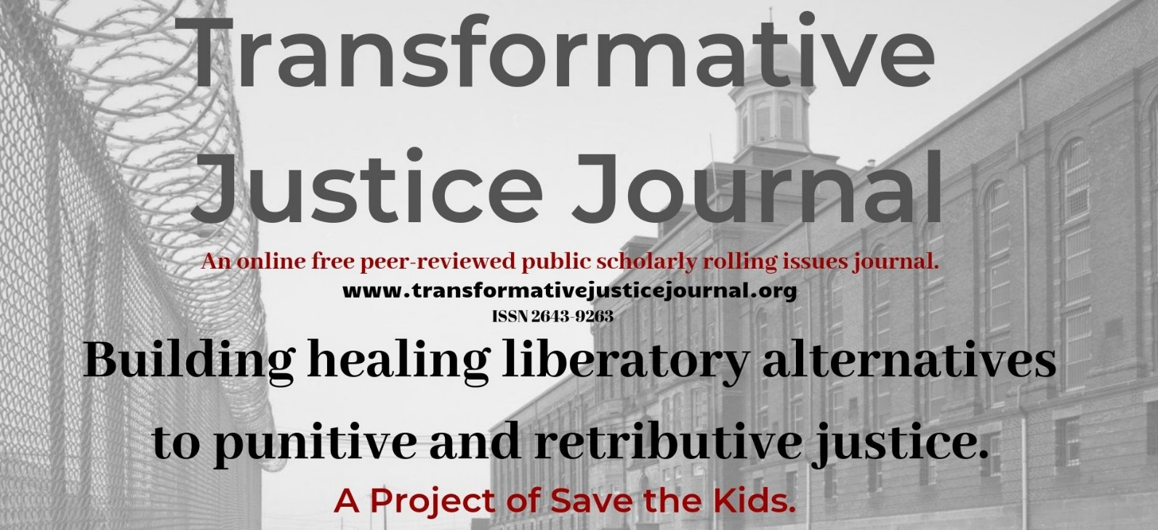

Volume 2, Issue 2, 2020

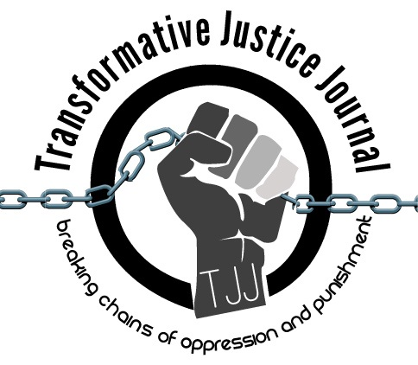

TABLE OF CONTENTS

About Transformative Justice Journal ……………………………………………………………………….. 2

Location ……………………………………………………………………………………………………… 2
Editorial Team …………………………………………………………………………………………… 2 – 3

Submission Guidelines ………………………………………………………………………………… 3 - 5

Book Review
Beyond Survival: Strategies and Stories from the Transformative Justice Movement …………………....7-12
By Ejeris Dixon and Leah Lakshmi Piepzna-Samarasinha. Chico, CA: AK Press, 2020
Mechthild Nagel

ABOUT TRANSFORMATIVE JUSTICE JOURNAL
The Transformative Justice Journal (TJJ), founded in 2012, is an online, open-source, peer-reviewed scholar-activist, anti-authoritarian, subversive, and critical penal abolition journal dedicated to promoting transformative justice. TJJ is organized and edited by a radical critical grass-roots collective of activist-scholars, community organizers, and current and former prisoners from around the world. TJJ was influenced out of conversations at the International Conference on Penal Abolition ICOPA in 2010. As a scholar-activist journal, TJJ was developed out of scholarly and community dialogues around promoting a decolonizing and anarchist criminology social justice penal abolition community-based alternatives to both the retributive, punitive, and utilitarian justice models used by most colonial criminal justice systems, which victimize offenders and re-victimize survivors of offenses, while promoting profits over people and corporate interests over community interests. The current punitive criminal justice system takes control, responsibility, healing, and accountability away from victims and offenders and instead gives them a powerless and victimizing experience. Transformative justice, a decolonizing and anti-oppression approach, however, views conflict not from the lens of the criminal justice system, but from the community; as such, those involved in the conflict are seen as individuals rather than victims or offenders. Moreover, transformative justice works to dismantle oppression by systems of domination, such as racism, sexism, homophobia, ageism, elitism, statism, classism, transphobia, ecocide, speciesism, and ableism within all domestic, interpersonal, global, and community conflicts that foster theories such as, but not limited to eugenics, capitalism, and colonialism. In short, transformative justice is restorative justice plus social justice. Transformative justice expands the social justice model, which challenges and identifies injustices, in order to create organized processes of addressing and ending those injustices and providing space and place for marginalized voices. Transformative justice also builds off the principles of, anarchism, decolonizing, prison abolition, healing justice, Quakerism, liberation, revolutionary social justice resistance movements, First Nations in Canada, and restorative justice in order to dismantle oppression, repression, suppression, and domination.

LOCATION

The Transformative Justice Journal is located in the Department of Criminal Justice at Salt Lake Community College.
Dr. Anthony J. Nocella II
Managing Editor
Department of Criminal Justice
Salt Lake Community College
Larry H. Miller Campus
Public Safety Education and Training Center
Office 270 D
410 West 9800 South
Sandy, Utah, USA 84070

EDITORIAL TEAM
Editor
- Arash Daneshzadeh
transformativejusticejournal@gmail.com
Managing Editor
- Dr. Anthony J. Nocella II
Salt Lake Community College
Associate Editors
- Dr. Jason Campbell
Nova Southeastern University
- Dr. Nancy Heitzeg
St. Catherine University
- Dr. Lea Lani Kinikini
Salt Lake Community College
- Dr. Mecke Nagel
SUNY Cortland
- Dr. Judah Schept
Eastern Kentucky University
Incarcerated People Liaison
- Lucas Alan Dietsche
University of Wisconsin-Platteville
Save the Kids
lucasdietsche81@gmail.com
Book Reviewers
- Dr. Ben Brucato
Rhode Island College
- Mark Lafrenz
University of Buffalo
Article Reviewers
- Chelsie Joy Acosta
National Week of Action Against Incarcerating Youth
- Dr. Dean Adams
University of Illinois, Chicago
- Dr. Rose M. Brewer
University of Minnesota
- Dr. John P. Broome
University of Mary Washington
- MayKela Breeye Cox
Journey of Hope
- Dr. Michael J. Coyle
California State University, Chico
- Paulette D’auteuil
International Leonard Peltier Defense Committee and Jericho Movement
- Siobhan DeJesus
Buffalo Anti-Racism Coalition
- Dr. Jason Del Gandio
Temple University
- Dr. Máel Embser-Herbert
Hamline University
- Dr. Andrej Grubacic
California Institute of Integral Studies
- Jordan Halliday
Poetry Behind the Walls
- Dr. Daniel White Hodge
North Park University
- Matthew Holman
Utah Reintegration Project
- Daphne Jackson
Struggle for African Liberation
- Zhandarka Kurti
The University of Tennessee, Knoxville
- Kati Lewis
Salt Lake Community College
- Catherine Mendonca
San Diego Tenants Union
- Alisha Page
Save the Kids
- Dr. Priya Parmar
CUNY Brooklyn
- Dr. Sean Parson
Northern Arizona University
- Dr. Dylan Rodriguez
University of California, Riverside
- Zakiya Sankara-Jabar
Racial Justice NOW!
- Dr. Mark Seis
Fort Lewis College
- Dr. Beverly Yuen Thompson
Siena College
- Brian Trautman
Berkshire Community College

SUBMISSION GUIDELINES

Please read these guidelines and then send your article, essay, review, research notes, interviews, reflections, poems, art, event summary, etc. to: transformativejusticejournal@gmail.com

Value and Uniqueness of TJJ

- The Transformative Justice Journal was influenced in 2010 by discussions at the International Conference on Penal Abolition (ICOPA).
- The Transformative Justice Journal publishes rigorously peer-reviewed scholar-activist work of the highest quality.
- The Transformative Justice Journal provides the utmost respect and care during the review process.
- The Transformative Justice Journal is a free-to-access electronic journal.
- The Transformative Justice Journal charges no fees for publication.
- The Transformative Justice Journal supports and encourages submissions that are excluded from mainstream journals, such as, but not limited to use photographic, video, MP3, art, poems, raps, and new media work.
- The Transformative Justice Journal, is organized and edited by a radical critical grass-roots collective of activist-scholars, community organizers, and current and former prisoners from around the world.

We Seek

- incarcerated writings and art – of any length
- research articles and essays – 2,000 to 10,000 words
- student final papers – no more than 10,000 words
- course/class summaries – no more than 2,000 words
- research notes – no more than 2,000 words
- commentary – no more than 2,000 words
- tactic and strategy analysis – no more than 10,000 words
- academic development – no more than 10,000 words
- lecture/presentation summaries – no more than 2,000 words
- conference/panel summaries – no more than 2,000 words
- events/protests/resistances summaries – no more than 2,000 words
- action alert summaries – no more than 2,000 words
- film, book, art, and media reviews – no more than 3,000 words
- interviews and dialogues – between 1,000 to 10,000 words
- poems and rap – no more than 10,000 words

Style

- All submissions should have appropriate references and citations. Manuscripts should be single line spacing, 12-point font and conform to the American Psychological Association (APA) style format.
- Submissions must be sent in Microsoft Word format. Submissions in other software formats will not be reviewed.
- Authors should remove all self-identification from their submissions, but all submissions must be accompanied by a title page with author(s) name and affiliation, name of type of submission (e.g., article, review, conference summary, etc.), contact information including e-mail, postal address, and phone number.
- Authors must include an abstract of no more than 150 words that briefly describes the manuscript’s contents.

Review Process

- Upon acceptance for review, the Transformative Justice Journal editors will send manuscripts, under a double-peer reviewed process, to no less than two, and generally three reviewers. Reviewers provide their recommendations to the editor, who makes the final decision to accept the manuscript.
- The Transformative Justice Journal holds to the utmost respect, love, and care when reviewing manuscripts. Each review we assure is constructive, positive, and hopefully useful to the author. We strongly welcome first time authors, students, nontraditional students, activists, youth, community organizers, prisoners, politicians, and teachers.

Submissions will be assigned to one of the four following categories:

1. accept without revisions
2. accept with editorial revisions
3. revise and resubmit for peer review
4. reject

- Every effort will be made to inform authors of the editor’s decision within 100 days of receipt of a manuscript. Authors, whose manuscripts are accepted for publication, will be asked to submit a brief biography that includes their institutional or organizational affiliations and their research interests. The Transformative Justice Journal only publishes original materials. Please do not submit manuscripts that are under review or previously published elsewhere.

Copyright, Republishing, and Royalties

- All Work published by the Journal is copyrighted by the Transformative Justice Journal.
- Republication of Contributor’s Submitted Work may be assessed a reasonable fee for the administration and facilitation to other presses. Such fee shall be determined at the discretion of the Transformative Justice Journal.
- Royalties: Contributor agrees and acknowledges that no royalty, payment, or other compensation will be provided by the Transformative Justice Journal in exchange for or resulting from the publication of the Submitted Work.

Publication Dates

TJJ uses a rolling submission process, allowing authors to submit at any time during the year without time restraints or quota of articles in an issue. Rolling submission, the most current scholarly method of accepting publications, allows for more timely publications and current scholarship to enter the public sphere in a more timely fashion, rather than conforming to traditional academic print journal guidelines.
We are pleased to accept your submissions at any time and will move quickly through the review process to ensure timeliness.

For submission, please submit to:

- transformativejusticejournal@gmail.com

Volume 2, Issue 2, 2020
___________________________________________________________________________
Book Review

Beyond Survival: Strategies and Stories from the Transformative Justice Movement
By Ejeris Dixon and Leah Lakshmi Piepzna-Samarasinha. Chico, CA: AK Press, 2020
Author: Mechthild Nagel
Title: Professor
Institute: SUNY Cortland
Address: Department of Philosophy
POB 2000, Cortland, NY 13045 USA
E-mail: mecke.nagel@cortland.edu
Biography: Mechthild Nagel is professor of Philosophy and Africana Studies at the State University of New York, College at Cortland and a visiting professor at Fulda University of Applied Sciences, Germany. Her most recent coedited books are Diversity, Social Justice, and Inclusive Excellence: Transdisciplinary and Global Perspectives (with S.N. Asumah, SUNY Press, 2014), which received the 2016 Book Award from the New York African Studies Association, and The End of Prisons: Reflections from the Decarceration Movement (with A. Nocella, Rodopi Press, 2013). Dr. Nagel is founder and editor-in-chief of the online feminist journal Wagadu: A Journal of Transnational Women’s and Gender Studies (wagadu.org).
Four Keywords: Transformative Justice; Book Review; Activism; Stories
___________________________________________________________________________

Beyond Survival: Strategies and Stories from the Transformative Justice Movement
By Ejeris Dixon and Leah Lakshmi Piepzna-Samarasinha. Chico, CA: AK Press, 2020
Mechthild Nagel
Introduction

Beyond Survival is a collection of essays and documents that gives a critical roadmap to activists who are committed to penal abolition. So much literature is devoted to a critique of the penal/carceral system, but very little is written about transformative justice and what it looks like on the ground. This volume is a sequel to the groundbreaking anthology The Revolution Starts at Home: Confronting Intimate Violence within Activist Communities (2016) by Incite! members and survivors of sexual assault. That book, started as a long zine, published by Critical Resistance, the foremost organization on penal abolition led by LGBTQ activists of color in the US. When violence occurs amidst members of marginalized communities and movement organizations, what interventions work which do not draw in the usual police powers of the state?

Beyond Survival also grapples with this critical abolitionist question and offers a plethora of perspectives on the process of community accountability. It is essential reading for all activists, scholars, and teachers, who already participate in healing circles, mediation, restorative justice practices, and it is also for those skeptics, who still cannot imagine a future without policing and punishment.

The book is published at a perfect time. A renewed, energized Movement for Black Lives in the wake of George Floyd’s lynching by Minneapolis police suddenly turns to more radical demands than last time, in 2014, when Black Lives Matter became more than a hashtag. We learn of rallying cries for “defunding the police” and community participation in city budget allocations across the US. More astonishingly, mainstream media conversations circle around abolition of police and prisons, something penal abolitionists could not have imagined when Angela Y Davis’s Are Prisons Obsolete? (2003) was published.

It is also significant to comment on the contributors’ politics of location. Much of abolitionist literature, whether it is books, zines, blogs, has been produced by BIPOC community activists, and their intersectional analysis has greatly shaped the conversation on penal abolition within the last three decades. Its beginnings can be traced to the Black lesbian group of socialist feminist Barbara Smith and others, who penned the classic Combahee River Collective’s Statement in 1977. On the west coast of the US, BIPOC activists began to address the onslaught of mass incarceration with the group Critical Resistance, with founding members, including Black feminist scholar-activists Angela Y Davis, Ruthie Gilmore, Julia Chinyere Oparah, and with INCITE! Women, Gender Non-Conforming and Trans people of Color Against Violence. Both of the groups have held major conferences and published critiques of the prison industrial complex. Another major influence on the intersectional, radical approaches to dismantle carceral logic in all its forms comes from the Safe OUTside the System collective of the Brooklyn-based Audre Lorde Project (New York City). What is the vision of staying safe outside the system? This question is taken seriously and interrogated in this new book Beyond Survival

In four parts, the editors collect stories and analysis about beginnings of building community safety (part one), offering case studies (part two) from regional organizations such as Georgia Latino Alliance for Human Rights (GLAHR), Mijente, and Puente Arizona, Philly Stands Up!, Bay Area Transformative Justice Collective, Creative Interventions, Oakland Power Projects, The Fireweed Collective and from national organizations such as Trans Lifeline. In addition, a toolkit from Lara Brooks and Mariame Kaba and the Safer Party Toolkit from the Safe OUTside the System (SOS) Collective, Audre Lorde Project equip us with important insights if we wish to start our own community interventions. In part three and four, the ideal of transformative justice is interrogated, critiqued and reevaluated. Does it work? What if it produces more harm than good? And why is it still the best option to resist policing, prisons, detention and other carceral spaces?

As the editors explain in their introduction, the main purpose of Beyond Survival is the map out the “how to do transformative justice” (p. 9). As Ejeris Dixon, the founding program coordinator of the SOS Collective at the Audre Lorde Project, explains Black communities have always relied on community accountability and transformative justice in the face of anti-Black state terror (p. 16). State violence is only one aspect of harm—community organizations must be equipped with the skills to create safety strategies for those who run from intimate partner violence or confront harm perpetrated by members who are in leadership positions of community groups. The SOS Collective, based in Central Brooklyn, whose members are queer and trans people of color, has devised safety network strategies that include neighborhood outreach, building trust so that people selling drugs interrupt transphobic violence in the streets and business owners don’t call the cops. In case of medical emergencies, they set up alternative ways to avoid relying on the emergency 911 call center (pp. 17-20). In the US, the police often escort medical personnel. From the SOS toolkit, we learn the importance of designating folks to be well-versed in verbal de-escalation strategies at large gatherings (house parties or clubs). The kit explains in detail the roles of the decision point/team, de-escalators, dispatchers, and safe transporters (pp. 179-186).

Avoiding overreliance on 911 calls is also a key concern for staff members of the Trans Lifeline. It is a grassroots, peer-support crisis hotline which is for and by the trans community, as all operators are transgender. They will not engage in nonconsensual active rescue, except if there is a credible threat to a third party and if there is suspected child abuse and neglect (p. 135). Trans Lifeline explains that active rescue can actually increase the risk of suicide and also put the caller in harm’s way such as being placed by police in an involuntary psychiatric hold (pp. 136-37). Oakland Power Projects, which grew out of anti-policing discussions at Critical Resistance, offers role-play workshops for crisis situations. They learned from conversations with Oakland residents that health is a major issue, so that healthcare workers offer “Know Your Options” workshops on for different health-related emergencies, including opioid and overdose workshops, where they train participants in administering Naloxone (Narcan) (pp. 141-143). Another major theme of the volume is addressing the needs of survivors of (childhood) sexual abuse, and organizations such as Philly Stands Up! rely on the accountability approach of generationFIVE (2007). Amita Swadhin shares their experience of working with a community accountability approach confronting their dad and bonding with a sister over the shared traumatic experience in a chapter, titled “Transforming Family.”

What might be the dangers of community accountability? The editors and contributors address this vexing question throughout the volume. Kai Cheng Thom notes that a community accountability process should not focus on punishment of the harmer: “Having been witness to many community accountability processes that have seemed to create more harm for those involved, I must emphasize that survivor-led does not mean that those who identify as survivors are necessarily experts in transformative justice, not that the identified survivor in a dynamic of abuse should get to dictate what happens to the identified abuser” (p. 74). However, survivors get to tell their own stories and address their needs, which they usually do not get met in the criminal legal system (p. 75).

The Bay Area Transformative Justice Collective decided to use the term “pod” in their “pod-mapping” worksheet, because community accountability is too lofty and abstract (p. 119). The collective noticed that very few people have more than two dependable persons in their lives and the worksheet is designed to help folks building pod networks and strengthening relationships (pp. 124-25).

A common complaint about community accountability is that the process can be very long, even taking years to complete. Here Leah Lakshmi Piepzna-Samarasinha’s essay on “Cripping TJ” is instructive. She notes that many folks engaged in transformative justice work are also disabled and discloses that coping with panic attacks and PTSD makes this work quite challenging (p. 235). Importantly, we must recognize that disability “is a part of many stories of abuse” (p. 241). Accountability processes must be “accessible to our disabilities and neurodivergence” and not discredit the survivor’s stories (p. 244). A better way to approach the process is to insist that it occurs on “crip time,” borrowing from writer Ellen Samuels. Transformative justice has been described as the longest process in the world, and if one used the flexible approach as normative rather than rigid deadlines, the process would be allowed to take is course without folks panicking and making hasty judgment calls (p. 244-45).

Finally, Mariame Kaba, who has inspired much of the recent decade’s transformative justice work with her visionary grassroots approach in Chicago, warns that this work is not about developing experts (and, I might add, certification programs). It is different from mediation and restorative justice work, precisely, because it is flexible and context-situated (pp. 290-91). “CA processes at their most basic are about trust. And if you don’t have that, if somebody violates that trust, then the whole thing can just collapse upon itself” (p. 292).

Beyond Survival is a very promising book which shares inspiring strategies and stories about transformative justice practices. It describes the tensions within the movement around accountability work and should be a required read for all who know that another world is possible. It is a valuable supplemental reading in undergraduate courses about social movements and in peace and conflict studies. It is a book that grapples deeply with intersectional analysis and would produce great conversations in gender and sexuality courses. While the book describes movement work in the US, it should be able to inspire activist-scholars across the globe, especially the Global South.

References
Chen, C., J. Dulani, and L.L. Piepzna-Samarasinha. (2016). The revolution starts at home: Confronting intimate violence within activist communities. Chico, CA: AK Press.
Combahee River Collective. (1985). The combahee river collective statement: Black feminist organizing in the seventies and eighties. Albany, NY: Kitchen Table Press.
Davis, A.Y. (2003). Are prisons obsolete? New York, NY: Seven Stories Press.
generationFIVE. (2007). Toward transformative justice: A Liberatory approach to child sexual abuse and
other forms of intimate and community violence. San Francisco, CA: generationFIVE.
Oparah, J.C., B. Ritchie, A. Smith (eds.). (2006). Color of violence: The Incite! anthology. Boston, MA: South
End Press.

