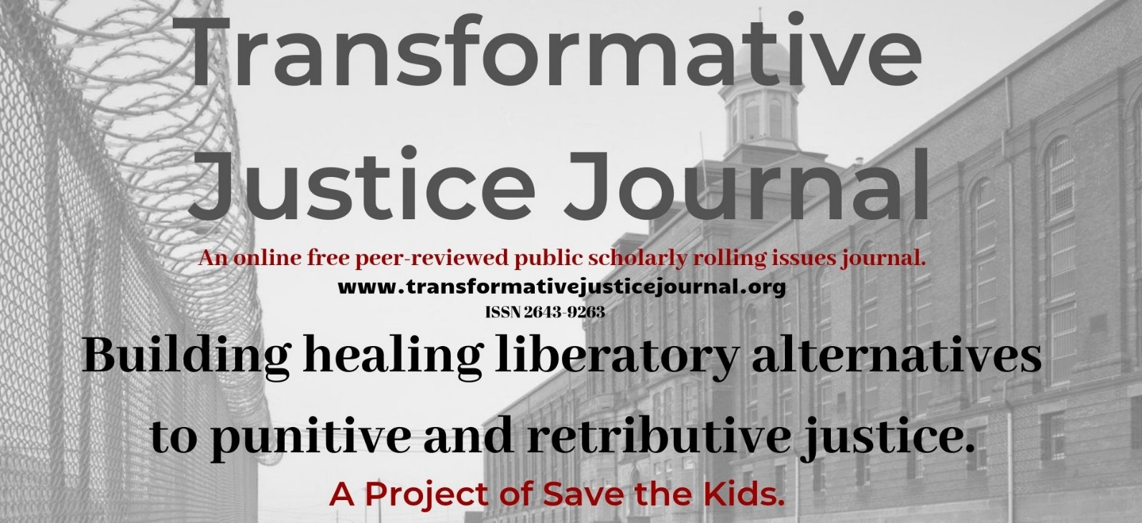

Volume 3, Issue 2, 2021

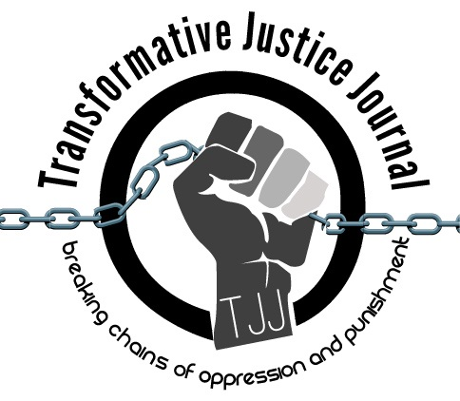

TABLE OF CONTENTS

About Transformative Justice Journal ……………………………………………………………………….. 2

Location ……………………………………………………………………………………………………… 2
Editorial Team …………………………………………………………………………………………… 2 - 3

Submission Guidelines ……………………………………………………………………………………3 - 5
Interview
Zane McNeill
Lucas Alan Dietsche………………………………..………………………………………………….........6-7

Poetry
Modern Cannibalism
Alfred Rhiner…………………………………………….………………………………………………….8-9

ABOUT TRANSFORMATIVE JUSTICE JOURNAL
The Transformative Justice Journal (TJJ), founded in 2012, is an online, open-source, and peer-reviewed journal dedicated to promoting transformative justice. As an academic-activist journal, TJJ was developed out of scholarly and community dialogues around promoting a decolonizing critical criminology social justice punitive/penal justice abolition community-based alternatives to both the retributive, punitive justice and utilitarian punishment models used by criminal justice systems, which victimize offenders and re-victimize survivors of offenses, while promoting profits over people and corporate interests over community interests. The current punitive criminal justice system takes control, responsibility, healing, and accountability away from victims and offenders and instead gives them a powerless and victimizing experience. Transformative justice, a decolonizing and anti-oppression approach, however, views conflict not from the lens of the criminal justice system, but from the community; as such, those involved in the conflict are seen as individuals rather than victims or offenders. Moreover, transformative justice addresses oppression by systems of domination, such as racism, sexism, homophobia, ageism, elitism, classism, and ableism within all domestic, interpersonal, global, and community conflicts. In short, transformative justice is restorative justice plus social justice. Transformative justice expands the social justice model, which challenges and identifies injustices, in order to create organized processes of addressing and ending those injustices. Transformative justice and social justice work together in addressing this need. Transformative justice also builds off the principles of restorative justice in order to address experiences of oppression within mediation.

LOCATION

The Transformative Justice Journal is located at in the Institute for Public Safety at Salt Lake Community College.
Dr. Anthony J. Nocella II
Managing Editor
Institute of Public Safety
Salt Lake Community College
Larry H. Miller Campus
Public Safety Education and Training Center
Office 270 D
410 West 9800 South
Sandy, Utah, USA 84070

EDITORIAL TEAM
Editor
- Lucas Alan Dietsche
Adams State University
transformativejusticejournal@gmail.com
Managing Editor
- Dr. Anthony J. Nocella II
Salt Lake Community College
Associate Editors
- Dr. Kim Socha
Normandale Community College
- Dr. Nancy Heitzeg
St. Catherine University
- Dr. Judah Schept
Eastern Kentucky University
- Dr. Mecke Nagel
SUNY Cortland
- Dr. Jason Campbell
Nova Southeastern University

Incarcerated People Liaison
- Aubrey Lommel
Save the Kids
anlommel@gmail.com

Book Reviewer
- Mark Lafrenz
University of Buffalo
- Dr. Ben Brucato
Rhode Island College
Article Reviewer
- Dr. Mark Seis
Fort Lewis College
- Dr. Dean Adams
University of Illinois, Chicago
- Dr. Jason Del Gandio
Temple University
- Dr. Daniel White Hodge
North Park University
- Dr. Priya Parmar
CUNY Brooklyn
- Dr. Beverly Yuen Thompson
Siena College
- Brian Trautman
Berkshire Community College
- Dr. Máel Embser-Herbert
Hamline University
SUBMISSION GUIDELINES

Please read these guidelines and then send your article, essay, review, research notes, conference summary, etc. to the appropriate Associate Editor (see below).
Value and Uniqueness of TJJ
- The Transformative Justice Journal publishes rigorously peer-reviewed academic work of the highest quality.
- The Transformative Justice Journal provides the utmost respect and care during the review process.
- The Transformative Justice Journal is a free-to-access electronic journal.
- The Transformative Justice Journal charges no fees for publication.
- The Transformative Justice Journal supports and encourages submissions that are excluded from mainstream journals, including the use of photographic, videom MP3, and new media work.
- The Transformative Justice Journal, while an academic journal provides space and place for activists contributions.

We Seek

- research articles and essays – 2,000 to 10,000 words
- student final papers – no more than 10,000 words
- course/class summaries – no more than 2,000 words
- research notes – no more than 2,000 words
- commentary – no more than 2,000 words
- tactic and strategy analysis – no more than 10,000 words
- academic development – no more than 10,000 words
- lecture summaries – no more than 2,000 words
- conference summaries – no more than 2,000 words
- event summaries – no more than 2,000 words
- action alert summaries – no more than 2,000 words
- film, book, art, and media reviews – no more than 3,000 words
- interviews and dialogues – between 1,000 to 10,000 words
- poems no more than 10,000 words
Style
- All submissions should have appropriate references and citations. Manuscripts should be single line spacing, 12-point font and conform to the American Psychological Association (APA) style format.
- Submissions must be sent in Microsoft Word format. Submissions in other software formats will not be reviewed.
- Authors should remove all self-identification from their submissions, but all submissions must be accompanied by a title page with author(s) name and affiliation, name of type of submission (e.g., article, review, conference summary, etc.), contact information including e-mail, postal address, and phone number.
- Authors must include an abstract of no more than 150 words that briefly describes the manuscript’s contents.
Review Process
- Upon acceptance for review, the Transformative Justice Journal editors will send manuscripts, under a double-peer reviewed process, to no less than two, and generally three reviewers. Reviewers provide their recommendations to the editor, who makes the final decision to accept the manuscript.
- The Transformative Justice Journal holds to the utmost respect, love, and care when reviewing manuscripts. Each review we assure is constructive, positive, and hopefully useful to the author. We strongly welcome first time authors, students, nontraditional students, activists, youth, community organizers, prisoners, politicians, and teachers.

Submissions will be assigned to one of the four following categories:
1. accept without revisions
2. accept with editorial revisions
3. revise and resubmit for peer review
4. reject

- Every effort will be made to inform authors of the editor’s decision within 100 days of receipt of a manuscript. Authors, whose manuscripts are accepted for publication, will be asked to submit a brief biography that includes their institutional or organizational affiliations and their research interests. The Transformative Justice Journal only publishes original materials. Please do not submit manuscripts that are under review or previously published elsewhere.

Copyright, Republishing, and Royalties
- All Work published by the Journal is copyrighted by the Transformative Justice Journal.
- Republication of Contributor’s Submitted Work may be assessed a reasonable fee for the administration and facilitation to other presses. Such fee shall be determined at the discretion of the Transformative Justice Journal.
- Royalties: Contributor agrees and acknowledges that no royalty, payment, or other compensation will be provided by the Transformative Justice Journal in exchange for or resulting from the publication of the Submitted Work.

Publication Dates
TJJ uses a rolling submission process, allowing authors to submit at any time during the year without time restraints or quota of articles in an issue. Rolling submission, the most current scholarly method of accepting publications, allows for more timely publications and current scholarship to enter the public sphere in a more timely fashion, rather than conforming to traditional academic print journal guidelines.
We are pleased to accept your submissions at any time and will move quickly through the review process to ensure timeliness.
For general submission, please submit to:
- transformativejusticejournal@gmail.com

Volume 3, Issue 2, 2021
___________________________________________________________________________
Interview with Zane McNeil

Author: Lucas Alan Dietsche
Title: Adjunct Professor
Institute: Adams State University
Address: PO BOX 1091, Superior, WI 54880
E-mail: lucasdietsche81@gmail.com
Biography: Lucas Alan Dietsche is a graduate of Criminology/Criminal Justice and member of the Division of Convict Criminology. He is the Editor of Transformative Justice Journal. He is an adjunct professor for print-based correspondence prison courses. He has many articles published on Poetic Inquiry Criminology and carceral feminism.

Four Keywords: Russell Maroon Shoatz, Political Prisoner, Black Liberation, Maroon History
__________________________________________________________________________

Interview with Zane McNeill
Lucas Alan Dietsche
Lucas Alan Dietsche: Hi Zane, can you discuss activism, school, groups, locality, future goals, and your connection Save the Kids, abolition, and transformative justice?

Zane McNeill: I have been involved in vegan advocacy and animal liberation work for over a decade and have since gotten involved in intersecting campaigns against carcerality, environmental degradation and environmental racism, and worker’s rights and labor advocacy. I have a collection forthcoming from Lantern Publishing next January on anti-carceral veganism and am currently involved with the groups Rights for Animal Rights Advocates (RARA), the Institute for Critical Animal Studies (ICAS), Sentient Media, and the Arissa Media Group.

LAD: How has COVID changed your vocation/institution/and personal life? What do foresee happening with the prison-industrial complex in a post-covid imperialist country?

ZM: COVID-19 actually gave me the opportunity to grow into this work. With everything moving to Zoom, I co-founded a company, Sparks and McNeill, LLC which is an editorial company specializing in public history, activist scholarship, and using theories concerning liberation to inform praxis. I have also been able to participate in book talks and conferences, teach courses, and be part of roundtables now that they are online and more accessible.
If anything, COVID illustrated how disposable the lives of incarcerated people are viewed by the State. Incarcerated folks were not provided with masks and hand sanitizer throughout the pandemic and were not vaccinated immediately when vaccines became available. Not only do we need to dismantle the prison-industrial complex, but we need to interrogate our own internalized carceral logics. That is why I believe activist scholarship is so important.
LAD: With the world coming to grips with last years rebellion against police brutality, racism, that has stemmed from the killing of George Floyd, and trying to figure out mass continuance of the struggle, what steps can academics, students, working-class, people of color, LGBTQIAA folx, prison activists, and abolitionists take within their community and nationally? What do you foresee taking place?

ZM: First off, we need to hold our ‘allies’ accountable. So many NGOs promised to do the work to make their internal cultures and external coalitions more equitable. So far, their statements have seemed hollow and performative. Vegan organizations, which I work with specifically, need to understand that doing one workshop on antiracism or hiring a new HR person specializing in DEI is not enough. Justice requires a redistribution of resources, as well as interrogating the missions, goals, and campaigns of your organization. The best thing these groups can do is raise the voices of historically marginalized peoples, fund these leaders, and be quiet.
LAD: What are your thoughts on how oppressed communities, academics, students, working-class, people of color, LGBTQIAA folx, prison activists, socialists, communists, anarchists,and abolitionists deal with Pride and police. What's your thoughts on police accountability, reform, and abolition?

ZM: I actually did my thesis on exactly this -- homonationalism, pinkwashing, and militarizing pride! I specifically tried to raise the amazing work of the Black Pride 4 and the Black Queer and Intersectional Collective. Not only is there no place for police at Pride -- who will target and endanger trans people of color and uphold white supremacy -- but there needs to be a complete defunding and dismantling of the Police State itself.
LAD: What books, research, and other resources have you been interested in towards transformative justice? What are other related topics would you like to share?
ZM: I have been most influenced by queer and trans activists of color who have written on total liberation and consistent anti-oppression, such as Breeze Harper, Christopher Sebastian, LoriKim Alexander, Margaret Robinson, Shiri Eisner, Miko Brown, and Julia Feliz.
I would also recommend watching this and reading the texts that are recommended:
https://activisthistory.com/2020/06/29/anti-carceral-veganism-webinar/
https://www.youtube.com/watch?v=ZhU9p8gWk4A
https://activisthistory.com/2020/01/13/tracing-the-color-of-queer-choreopolitics/
https://muckrack.com/z-zane-mcneill-1
https://sparksandmcneill.com/about-the-editors/
https://www.linkedin.com/in/zane-mcneill-1bb90a20a/
https://twitter.com/zane_crittheory

Volume 3, Issue 2, 2021
___________________________________________________________________________
Modern Day Cannibalism
Author: Alfred Rhiner
Title: Incarcerated adult
Institute: Florida Department of Corrections
Address: Alfred Rhiner #Y02241Y
Florida Department of Corrections
1150 SW Allapattah Road, Indiantown, FL 34956-4397
E-mail: N/A
Biography: N/A

Four Keywords: Russell Maroon Shoatz, Political Prisoner, Black Liberation, Maroon History
__________________________________________________________________________

Modern Day Cannibalism
Alfred Rhiner

Year in, year out.

We ask the legislature to bring about an opportunity to let us out.

Year in, year out.

The only thing without a doubt is that we lost another bout.

Is anyone keeping count of the losses that continue to mount?

They say this is democracy, the will of the People holds supremacy.

All I see is hypocrisy, borderline tyranny.
Bills pass unanimously, yet denied definitively.

Brandes, Pizzo, and Bracy, ignored... absolutely.
This democracy has become a watered down ideology.
Victims themselves speak passionately about giving a second opportunity.
But historically this doesn't benefit the monopoly.
Can't you see, it's all about gaining financially off the back of our economy.
What would you say to Florida having more Lifers today than Bama, Georgia, Texas, New York, and the great NWA?
Now, I'm not talking about individually, okay... It's a combined display!
20,000 lives laid out on a human buffet, feeding the rich a delicate gourmet... cannibalism of the modern day!
Wish to identify those who oppose you and I?
Let's not deny what can happen when we unify!
Together our voices will multiply, echoing throughout eternity.
No longer believing the lie, but willing to die we force the court to comply.
We put Life itself on trial, make it walk the Green Mile.
20,000 names we compile, have them all file.
Legislators do see how fragile, as the world is now mobile?
What happened to that slick little smile
Wow... whose number did you just dial?
(ringing) "911... What is your emergency?" (dial tone)

