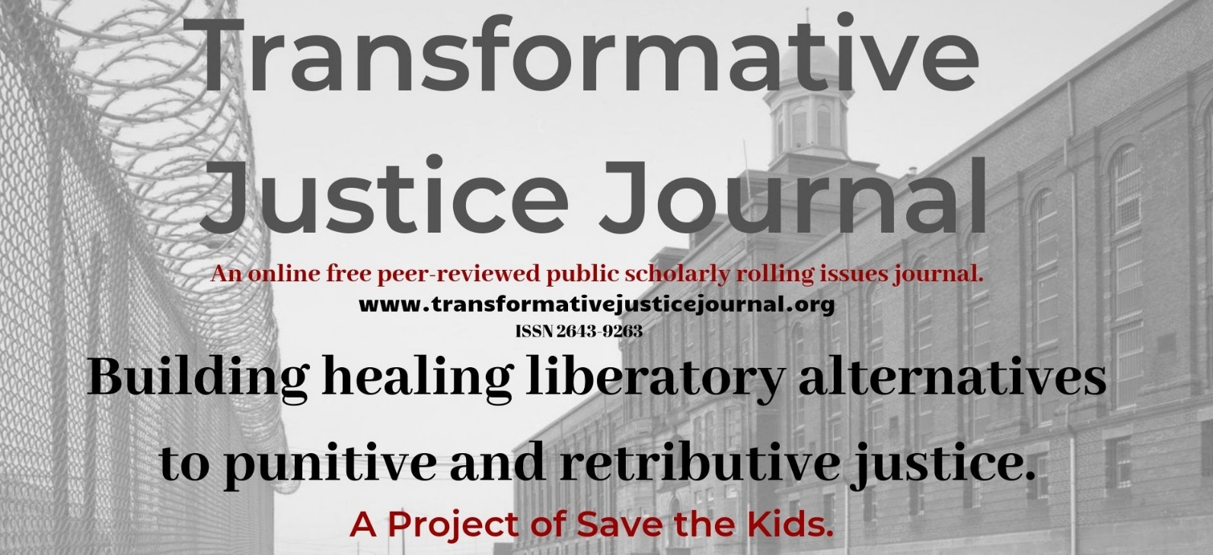

Volume 3, Issue 1, 2021

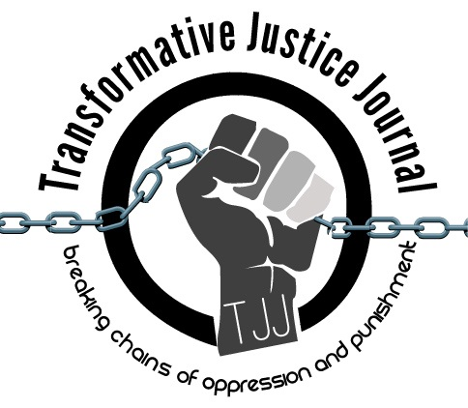

TABLE OF CONTENTS

About Transformative Justice Journal ……………………………………………………………………….. 2

Location ……………………………………………………………………………………………………… 2
Editorial Team …………………………………………………………………………………………… 2 - 4

Submission Guidelines ……………………………………………………………………………………4 - 6

Book Review
Classic Writings in Anarchist Criminology: A Historical Dismantling of Punishment and Domination....7-10
Anthony J. Nocella, Mark Seis, and Jeff Shantz. Oakland, CA: AK Press, 2020
Lucas Alan Dietsche

ABOUT TRANSFORMATIVE JUSTICE JOURNAL
The Transformative Justice Journal (TJJ), founded in 2012, is an online, open-source, peer-reviewed scholar-activist, anti-authoritarian, subversive, and critical penal abolition journal dedicated to promoting transformative justice. TJJ is organized and edited by a radical critical grass-roots collective of activist-scholars, community organizers, and current and former prisoners from around the world. TJJ was influenced out of conversations at the International Conference on Penal Abolition ICOPA in 2010. As a scholar-activist journal, TJJ was developed out of scholarly and community dialogues around promoting a decolonizing and anarchist criminology social justice penal abolition community-based alternatives to both the retributive, punitive, and utilitarian justice models used by most colonial criminal justice systems, which victimize offenders and re-victimize survivors of offenses, while promoting profits over people and corporate interests over community interests. The current punitive criminal justice system takes control, responsibility, healing, and accountability away from victims and offenders and instead gives them a powerless and victimizing experience. Transformative justice, a decolonizing and anti-oppression approach, however, views conflict not from the lens of the criminal justice system, but from the community; as such, those involved in the conflict are seen as individuals rather than victims or offenders. Moreover, transformative justice works to dismantle oppression by systems of domination, such as racism, sexism, homophobia, ageism, elitism, statism, classism, transphobia, ecocide, speciesism, and ableism within all domestic, interpersonal, global, and community conflicts that foster theories such as, but not limited to eugenics, capitalism, and colonialism. In short, transformative justice is restorative justice plus social justice. Transformative justice expands the social justice model, which challenges and identifies injustices, in order to create organized processes of addressing and ending those injustices and providing space and place for marginalized voices. Transformative justice also builds off the principles of, anarchism, decolonizing, prison abolition, healing justice, Quakerism, liberation, revolutionary social justice resistance movements, First Nations in Canada, and restorative justice in order to dismantle oppression, repression, suppression, and domination.

LOCATION

The Transformative Justice Journal is located in the Department of Criminal Justice at Salt Lake Community College.
Dr. Anthony J. Nocella II
Managing Editor
Department of Criminal Justice
Salt Lake Community College
Larry H. Miller Campus
Public Safety Education and Training Center
Office 270 D
410 West 9800 South
Sandy, Utah, USA 84070

EDITORIAL TEAM
Editor-In-Chief
- Lucas Alan Dietsche
University of Wisconsin-Platteville
transformativejusticejournal@gmail.com

Managing Editor
- Dr. Anthony J. Nocella II
Salt Lake Community College

Associate Editors
- Dr. Jason Campbell
Nova Southeastern University
- Dr. Nancy Heitzeg
St. Catherine University
- Dr. Lea Lani Kinikini
Salt Lake Community College
- Dr. Mecke Nagel
SUNY Cortland
- Dr. Judah Schept
Eastern Kentucky University

Incarcerated People Liaison
- Aubrey Lommel
University of Pennsylvania
amlommel@gmail.com

Book Reviewers
- Dr. Ben Brucato
Rhode Island College
- Mark Lafrenz
University of Buffalo

Article Reviewers
- Dr. Dean Adams
University of Illinois, Chicago
- Dr. Rose M. Brewer
University of Minnesota
- Dr. John P. Broome
University of Mary Washington
- MayKela Breeye Cox
Journey of Hope
- Dr. Michael J. Coyle
California State University, Chico
- Paulette D’auteuil
International Leonard Peltier Defense Committee and Jericho Movement
- Siobhan DeJesus
Buffalo Anti-Racism Coalition
- Dr. Jason Del Gandio
Temple University
- Dr. Máel Embser-Herbert
Hamline University
- Dr. Andrej Grubacic
California Institute of Integral Studies
- Jordan Halliday
- Dr. Daniel White Hodge
North Park University
- Matthew Holman
Utah Reintegration Project
- Daphne Jackson
Struggle for African Liberation
- Zhandarka Kurti
The University of Tennessee, Knoxville
- Kati Lewis
Salt Lake Community College
- Catherine Mendonca
San Diego Tenants Union
- Alisha Page
Save the Kids
- Dr. Priya Parmar
CUNY Brooklyn
- Dr. Sean Parson
Northern Arizona University
- Dr. Dylan Rodriguez
University of California, Riverside
- Zakiya Sankara-Jabar
Racial Justice NOW!
- Dr. Mark Seis
Fort Lewis College
- Dr. Beverly Yuen Thompson
Siena College
- Brian Trautman
Berkshire Community College

SUBMISSION GUIDELINES

Please read these guidelines and then send your article, essay, review, research notes, interviews, reflections, poems, art, event summary, etc. to: transformativejusticejournal@gmail.com

Value and Uniqueness of TJJ

- The Transformative Justice Journal was influenced in 2010 by discussions at the International Conference on Penal Abolition (ICOPA).
- The Transformative Justice Journal publishes rigorously peer-reviewed scholar-activist work of the highest quality.
- The Transformative Justice Journal provides the utmost respect and care during the review process.
- The Transformative Justice Journal is a free-to-access electronic journal.
- The Transformative Justice Journal charges no fees for publication.
- The Transformative Justice Journal supports and encourages submissions that are excluded from mainstream journals, such as, but not limited to use photographic, video, MP3, art, poems, raps, and new media work.
- The Transformative Justice Journal, is organized and edited by a radical critical grass-roots collective of activist-scholars, community organizers, and current and former prisoners from around the world.

We Seek

- Incarcerated writings and art – of any length
- Research articles and essays – 2,000 to 10,000 words
- Student final papers – no more than 10,000 words
- Course/class summaries – no more than 2,000 words
- Research notes – no more than 2,000 words
- Commentary – no more than 2,000 words
- Tactic and strategy analysis – no more than 10,000 words
- Academic development – no more than 10,000 words
- Lecture/presentation summaries – no more than 2,000 words
- Conference/panel summaries – no more than 2,000 words
- Events/protests/resistances summaries – no more than 2,000 words
- Action alert summaries – no more than 2,000 words
- Film, book, art, and media reviews – no more than 3,000 words
- Interviews and dialogues – between 1,000 to 10,000 words
- Poems and rap – no more than 10,000 words

Style

- All submissions should have appropriate references and citations. Manuscripts should be single line spacing, 12-point font and conform to the American Psychological Association (APA) style format.
- Submissions must be sent in Microsoft Word format. Submissions in other software formats will not be reviewed.
- Authors should remove all self-identification from their submissions, but all submissions must be accompanied by a title page with author(s) name and affiliation, name of type of submission (e.g., article, review, conference summary, etc.), contact information including e-mail, postal address, and phone number.
- Authors must include an abstract of no more than 150 words that briefly describes the manuscript’s contents.

Review Process

- Upon acceptance for review, the Transformative Justice Journal editors will send manuscripts, under a double-peer reviewed process, to no less than two, and generally three reviewers. Reviewers provide their recommendations to the editor, who makes the final decision to accept the manuscript.
- The Transformative Justice Journal holds to the utmost respect, love, and care when reviewing manuscripts. Each review we assure is constructive, positive, and hopefully useful to the author. We strongly welcome first time authors, students, nontraditional students, activists, youth, community organizers, prisoners, politicians, and teachers.

Submissions will be assigned to one of the four following categories:

- Accept without revisions
- Accept with editorial revisions
- Revise and resubmit for peer review
- Reject

- Every effort will be made to inform authors of the editor’s decision within 100 days of receipt of a manuscript. Authors, whose manuscripts are accepted for publication, will be asked to submit a brief biography that includes their institutional or organizational affiliations and their research interests. The Transformative Justice Journal only publishes original materials. Please do not submit manuscripts that are under review or previously published elsewhere.

Copyright, Republishing, and Royalties

- All Work published by the Journal is copyrighted by the Transformative Justice Journal.
- Republication of Contributor’s Submitted Work may be assessed a reasonable fee for the administration and facilitation to other presses. Such fee shall be determined at the discretion of the Transformative Justice Journal.
- Royalties: Contributor agrees and acknowledges that no royalty, payment, or other compensation will be provided by the Transformative Justice Journal in exchange for or resulting from the publication of the Submitted Work.

Publication Dates

- TJJ uses a rolling submission process, allowing authors to submit at any time during the year without time restraints or quota of articles in an issue. Rolling submission, the most current scholarly method of accepting publications, allows for more timely publications and current scholarship to enter the public sphere in a more timely fashion, rather than conforming to traditional academic print journal guidelines.
- We are pleased to accept your submissions at any time and will move quickly through the review process to ensure timeliness.
- For submission, please submit to: transformativejusticejournal@gmail.com

Volume 3, Issue 1, 2021
___________________________________________________________________________
Classic Writings in Anarchist Criminology: A Historical Dismantling of Punishment and Domination
Anthony J. Nocella, Mark Seis, and Jeff Shantz. Oakland, CA: AK Press, 2020
Author: Lucas Alan Dietsche
Title: Adjunct Professor
Institute: Adams State University
Address: POB 1091, Superior, WI 54880 USA
E-mail: lucasdietsche81@gmail.com
Biography: Lucas Alan Dietsche is an adjunct professor of Sociology at the Prison College Program through Adams State University at Alamosa, Colorado. Dietsche is the National Coordinator of Save the Kids'-Letters to Prisoners Project. He is the current-Poet Laureate, of Taconite Harbor, MN. His published works include “Commies and Zombies”, “Since the Oregon Trail”, “Moods are Like Wisconsin Weather”, and “Kapshida.” He has published poetry in Transformative Justice Journal, Ariel Anthology, and Nemadji Review.
Four Keywords: Transformative Justice; Book Review; Activism; Stories
___________________________________________________________________________

Classic Writings in Anarchist Criminology: A Historical Dismantling of Punishment and Domination
Anthony J. Nocella, Mark Seis, and Jeff Shantz. Oakland, CA: AK Press, 2020
Lucas Alan Dietsche
Introduction

Classical Writings is a collection of theoretical, historical critiques, and essays describing the class nature of the criminal justice system, and abolitionist struggles. The works give accounts of anarchist thinking regarding many questions at the time as well as a blueprint for transformative justice and abolition. Classic Writings present the continuity that anarchists have regarding state violence, crime creation, social order, in the paradigm of criminology.

Classic Writings historiography presents the timeline of prominent anarchist philosophers, theoreticians, activists, and criminological thinkers on the content of the state, police, the apparatus of the justice system, and state violence. The book has been compiled for the purposes of cataloging anarchism has been rooted in praxis, theory, and front-line activism. The book is perfect for activists, convict and abolitionist criminologists, as well as incarcerated activists curious to learn about the historical classics of theoretical pedagogy regarding police, prisons, and punishment of state control through criminal justice.

At an epoch of many political groups, mass movements of youth, and many politicians calling for the abolishment of the police as well as prisons, Classical Writings describes the role of the punitive state enforcing bourgeois class power. The book through many of its sources describes the oppressor over the oppressed for the main purpose of law and order. Many of the writers, from the time of Goodwin to Goldman describe the inherent societal disadvantages of the working-poor criminalized for trying to redress conditions, living, and social concerns. Freedom and democracy for which the bourgeoise taunts for its own purpose is denied to lower classes in substance, legitimizing bourgeoise rule.

The literature has been created by many founders of anarchist writing from the early 1800’s to the early part of the 20th century. This was an era of heavy expansion of capitalism in the United States, the post-Civil War boom, and massive centers of industrialization. With these expansions, urbanization of cities, the proletarianization of rural people, and the deep stratification of gender, race, and class. The need for a more modern bureaucratized and categorized police force, to watch over and control the mass European immigration and radical movements. Prisons were expanded from the use of religious penance/penitentiaries to the use of modern prisons for demonstrative correction and segregation of crimes. Writers touch on the contradictions of malfeasance by working-classes that are criminalized mainly for survival. The book complements Davis's book title question “Are Prisons Obsolete?” to the observation of Kropotkin's quote “Are Prisons Necessary? (Davis, 2003).”

The First Parts of Classical Writings contain early writings on what the meaning of the class composition and what purposes does the state serve. In Part One, Godwin describes the Western Enlightenment creation of law as the validation of state coercion. Within this internal versus systematic conflict, between community and free-will, it is apparent that coercion cannot guarantee the oppressed class a social peace. He delineates that if there is the continuum saga of conflict, instability, and punishment in the eyes of justice, then there can be no moral ground in that society. The use of force to qualm peaceful protests is constantly challenged by the oppressed marginalized communities.

Part Two contains writings of Proudhon, writing a great deal on how property is the basis of crime. His analysis on class privileges shows that only men with property can be creators of law. Propertied- men are considered safer from criminal law persecution, and by law own social property. Proudhon writes that legal code “is the expression of a social want, the declaration of a fact: the legislator does not make it, he declares it (p. 74).” Laws, legalism, and legislature are not created without class expression of property behind them.

Part 3 and 4 serves to address the more outright violence of the state from the perception of activism. Bakunin and Spies were anarchists that were for organizing working classes through united groups. Bakunin writes on capitalist state ethics and morals regarding capital punishment, criminal justice punitive sanctions, and capitalist judgement are synonymous with state interests. Not only did Bakunin refute that the so-called social contract has popular validity, or has any sort of positive impact upon working classes. Bakunin writes a practical program regarding capitalist justice that must happen along with state abolition.
In Part Four, anarchist activist Spies was one of the accused of the Haymarket Square bombing. In Classical Writing Spies presents defense as a place to record his positions against the State. In his speech, he describes that crime is a barometer of how the state is functioning through its social order norms. The harbinger of modern class civilization is founded on the evolution of state crime. Spies defend anarchist principles against state-sanctioned terror through execution, violence, and non-physical manipulation through the press and religion. Crime is not the popular held notion of individual law betrayal and individual deviance.

Parts Five and Six enter Kropotkin, Schawb, and Gary. Kropotkin’s chapter title called “Are Prison necessary?” is one that continues to be written and critiqued about. Kropotkin writes “Prisons do not moralize their inmates; they do not deter them from crime (p.153).” Kropotkin criticizes the works of the founder of modern criminology Lombroso. It was Lombroso-the creator of modern criminology that introduced research and methodology techniques. Lombroso is also heavily criticized for researching a sophist biological criminology that believes criminal behavior can be judged by certain physical stereotypes. Kropotkin writes on law and authority criticizing that legalism is the remedy to a pendulum swing in criminal justice, but only beholden to ruling classes. Kropotkin surmises that only after a revolution, can law guarantee workers’ rights to their labor.

In Part Six, Schwab and Gary give great contributions from a convict criminological perspective of Lombroso. Both argue against Lombroso and that persons with criminal activity harbor similar biology and facial structure. From an authentic perspective of lived experience, Schwab and Gary defend the anarchist activist-writers for their survival crimes and activities. Their point-of-view is how the system attacks oppressed persons. From that consciousness grows with theory and praxis through capitalists' own constant vindication.

Part Seven, Malesta writes about the structure of police as well as long-term goals of police abolition. As an activist, Malestra understood the labor struggles with police as defenders of property law and order. Malestra’s message is clear for the new generation of revolutionaries of today that struggle with police accountability and abolition. Malestra writes how it is important to find alternatives to police to make them useless and superfluous to the community.

In Part Eight, De Cleye, touches on the differences of personal and social consciousness which becomes ambiguous and possible in conflict with abolitionists. Social consciousness being constantly educated and forming liberation opportunities. De Cleye contends that whichever camp is social-conscious, De Cleye writes that blind faith in total incarceration, superstition. Legalism and ostracization will never separate capitalism from crime. Again, Lombroso is dissected because what De Cleye claims is that what constitutes crime is constantly evolving. De Cleye’s thoughts on whether the three classes of criminals: Born Criminal, Criminaloid, and Accidental Criminal are deep focuses of discussion within academic circles, especially continuously using a ethnographic lens.

In Classical Writings Parts Nine, Ten, and Eleven concludes with anarchist activists and critiques of crime in the early part of the 1900’s. In Nine, Parsons discusses the polemics of forming the alternatives for prisons. Parsons talks about the right of the State to abuse, control, and condemn marginalized persons within the state. Parson discusses what constitutes legal force through a manifesto of anarchism, including a life without prisons. Whether political change happens the next day, or there is a long struggle leading up to it, Parsons argues that small reforms are valid if the long-term goals are fought for. Abolitionist activists need to read this essential text to deliberate what constitutes short and long-term goals.

Part 10, Berkman addresses stigma, criminalization, and prison reformation. Berkman writes about the formerly incarcerated person’s stigma, and ostracization from friends and family, which is a continuing problem today. As well as many feminists, revolutionaries, and abolitionist activists wrestle with how to incorporate formerly incarcerated persons within their ranks or as leaders. Berkman addresses philanthropic support for reform to address crime. The penitentiaries, prisons, workshops were replaced with reformatories, but this was only in name only. These buildings were only the latest craze in the early 1900’s to try to deal with the criminal as an individual problem by private social means. Simply without walls, Berkman writes “kindness is truly reformative (p. 245).”
Anarchist Criminology adheres to the continuing struggle of decriminalization of sex workers as addressed in Part 11. Goldman, tackles the questions of sex work legalization, as well as criticizes liberal and reform feminists. These carceral feminist groups defend the carceral state use of violence and apparatus to deter prostitution. The capitalist state is a guilty harbinger of domestic and international violence. Supporting the state as the “good cop” would give legitimacy to the violence-creators. Goldman writes on how “society is using the most drastic methods in dealing with the social offender (p. 275).” This means society putting more money into the prisons and guards, without any desired positive effect.

Classical Writings is a great collection of the very beginnings of the theoretical, praxis, convict perspective for abolition, and anarchist criminology. This book presents that anarchists have, from the beginning, been written by, conscious of, in solidarity of, and allied towards political and common-law prisoners. The book is valuable for prison and police abolition, but surely as the explanation of the foundations of prisons and their peripheral apparatus as an intricate part of capitalist identity.

References
Davis, A.Y., (2003). Are Prisons Obsolete? New York, NY: Seven Stories Press.
Ferrell, J. (2009). Against method, against authority… for anarchy. Contemporary anarchist studies. Milton Park, UK: Routledge.
Kletsan, P. (2018). Revolution and Restorative Justice: An Anarchist Perspective. Abolition: A Journal of Insurgent Politics, (1), 195-206.
Nocella, A. J., Seis, M. C., Shantz, J., Kinna, R., & Fernandez, L. A. (2020). Classic writings in Anarchist Criminology: A historical dismantling of punishment and domination.
Ruth-Heffelbower, D. (2011). Anarchist criminology: a new way to understand a set of proven practices. http://hdl.handle.net/11418/617

