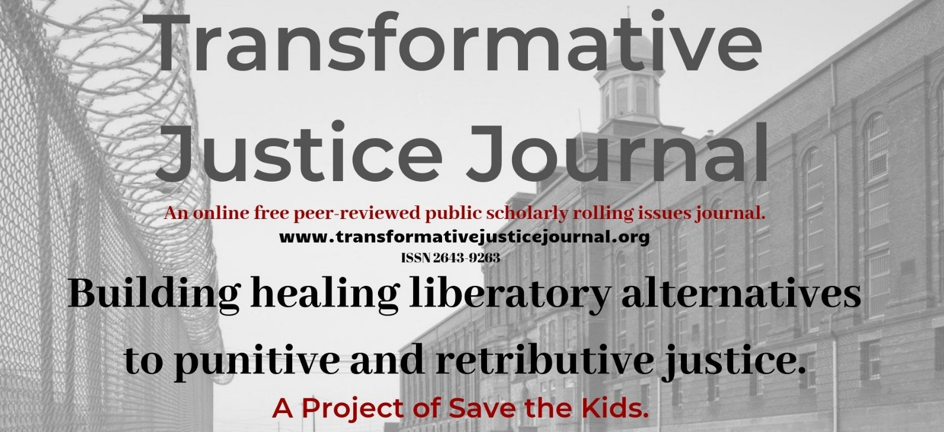

Volume 3, Issue 3, 2021

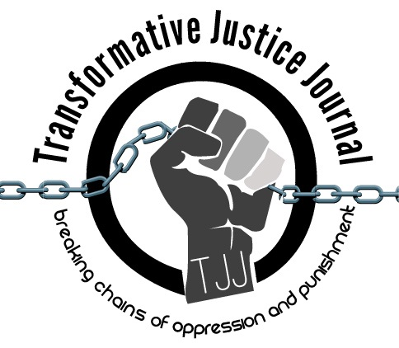

TABLE OF CONTENTS

About Transformative Justice Journal ………………………………………………………………………. 2

Location ……………………………………………………………………………………………………… 2
Editorial Team …………………………………………………………………………………………… 2 - 4

Submission Guidelines ……………………………………………………………………………………4 - 6

Interview
Trevor A. Brown…………………………………………………………………….……………………..7-10
Lucas Alan Dietsche

Poetry
It's a lifestyle (Ode to p t s d) ……………….……………….………………………………………..….11-12
Charles Tooker

ABOUT TRANSFORMATIVE JUSTICE JOURNAL
The Transformative Justice Journal (TJJ), founded in 2012, is an online, open-source, peer-reviewed scholar-activist, anti-authoritarian, subversive, and critical penal abolition journal dedicated to promoting transformative justice. TJJ is organized and edited by a radical critical grass-roots collective of activist-scholars, community organizers, and current and former prisoners from around the world. TJJ was influenced out of conversations at the International Conference on Penal Abolition ICOPA in 2010. As a scholar-activist journal, TJJ was developed out of scholarly and community dialogues around promoting a decolonizing and anarchist criminology social justice penal abolition community-based alternatives to both the retributive, punitive, and utilitarian justice models used by most colonial criminal justice systems, which victimize offenders and re-victimize survivors of offenses, while promoting profits over people and corporate interests over community interests. The current punitive criminal justice system takes control, responsibility, healing, and accountability away from victims and offenders and instead gives them a powerless and victimizing experience. Transformative justice, a decolonizing and anti-oppression approach, however, views conflict not from the lens of the criminal justice system, but from the community; as such, those involved in the conflict are seen as individuals rather than victims or offenders. Moreover, transformative justice works to dismantle oppression by systems of domination, such as racism, sexism, homophobia, ageism, elitism, statism, classism, transphobia, ecocide, speciesism, and ableism within all domestic, interpersonal, global, and community conflicts that foster theories such as, but not limited to eugenics, capitalism, and colonialism. In short, transformative justice is restorative justice plus social justice. Transformative justice expands the social justice model, which challenges and identifies injustices, in order to create organized processes of addressing and ending those injustices and providing space and place for marginalized voices. Transformative justice also builds off the principles of, anarchism, decolonizing, prison abolition, healing justice, Quakerism, liberation, revolutionary social justice resistance movements, First Nations in Canada, and restorative justice in order to dismantle oppression, repression, suppression, and domination.

LOCATION

The Transformative Justice Journal is located in the Department of Criminal Justice at Salt Lake Community College.
Dr. Anthony J. Nocella II
Managing Editor
Department of Criminal Justice
Salt Lake Community College
Larry H. Miller Campus
Public Safety Education and Training Center
Office 270 D
410 West 9800 South
Sandy, Utah, USA 84070

EDITORIAL TEAM

Editors-In-Chief
- Lucas Alan Dietsche
Adams State University
transformativejusticejournal@gmail.com
- David Robles
Salt Lake Community College

Managing Editor
- Dr. Anthony J. Nocella II
Salt Lake Community College

Associate Editors
- Dr. Jason Campbell
Nova Southeastern University
- Dr. Nancy Heitzeg
St. Catherine University
- Dr. Lea Lani Kinikini
Salt Lake Community College
- Dr. Mecke Nagel
SUNY Cortland
- Dr. Judah Schept
Eastern Kentucky University

Incarcerated People Liaison
- Aubrey Lommel
University of Pennsylvania
amlommel@gmail.com

Book Reviewers
- Dr. Ben Brucato
Rhode Island College
- Mark Lafrenz
University of Buffalo

Article Reviewers
- Dr. Dean Adams
University of Illinois, Chicago
- Dr. Rose M. Brewer
University of Minnesota
- Dr. John P. Broome
University of Mary Washington
- MayKela Breeye Cox
Journey of Hope
- Dr. Michael J. Coyle
California State University, Chico
- Paulette D’auteuil
International Leonard Peltier Defense Committee and Jericho Movement
- Siobhan DeJesus
Buffalo Anti-Racism Coalition
- Dr. Jason Del Gandio
Temple University
- Dr. Máel Embser-Herbert
Hamline University
- Dr. Andrej Grubacic
California Institute of Integral Studies
- Jordan Halliday
- Dr. Daniel White Hodge
North Park University
- Matthew Holman
Utah Reintegration Project
- Daphne Jackson
Struggle for African Liberation
- Zhandarka Kurti
The University of Tennessee, Knoxville
- Kati Lewis
Salt Lake Community College
- Catherine Mendonca
San Diego Tenants Union
- Alisha Page
Save the Kids
- Dr. Priya Parmar
CUNY Brooklyn
- Dr. Sean Parson
Northern Arizona University
- Dr. Dylan Rodriguez
University of California, Riverside
- Zakiya Sankara-Jabar
Racial Justice NOW!
- Dr. Mark Seis
Fort Lewis College
- Dr. Beverly Yuen Thompson
Siena College
- Brian Trautman
Berkshire Community College

SUBMISSION GUIDELINES

Please read these guidelines and then send your article, essay, review, research notes, interviews, reflections, poems, art, event summary, etc. to: transformativejusticejournal@gmail.com

Value and Uniqueness of TJJ

- The Transformative Justice Journal was influenced in 2010 by discussions at the International Conference on Penal Abolition (ICOPA).
- The Transformative Justice Journal publishes rigorously peer-reviewed scholar-activist work of the highest quality.
- The Transformative Justice Journal provides the utmost respect and care during the review process.
- The Transformative Justice Journal is a free-to-access electronic journal.
- The Transformative Justice Journal charges no fees for publication.
- The Transformative Justice Journal supports and encourages submissions that are excluded from mainstream journals, such as, but not limited to use photographic, video, MP3, art, poems, raps, and new media work.
- The Transformative Justice Journal is organized and edited by a radical critical grass-roots collective of activist-scholars, community organizers, and current and former prisoners from around the world.

We Seek

- Incarcerated writings and art – of any length
- Research articles and essays – 2,000 to 10,000 words
- Student final papers – no more than 10,000 words
- Course/class summaries – no more than 2,000 words
- Research notes – no more than 2,000 words
- Commentary – no more than 2,000 words
- Tactic and strategy analysis – no more than 10,000 words
- Academic development – no more than 10,000 words
- Lecture/presentation summaries – no more than 2,000 words
- Conference/panel summaries – no more than 2,000 words
- Events/protests/resistances summaries – no more than 2,000 words
- Action alert summaries – no more than 2,000 words
- Film, book, art, and media reviews – no more than 3,000 words
- Interviews and dialogues – between 1,000 to 10,000 words
- Poems and rap – no more than 10,000 words

Style

- All submissions should have appropriate references and citations. Manuscripts should be single line spacing, 12-point font and conform to the American Psychological Association (APA) style format.
- Submissions must be sent in Microsoft Word format. Submissions in other software formats will not be reviewed.
- Authors should remove all self-identification from their submissions, but all submissions must be accompanied by a title page with author(s) name and affiliation, name of type of submission (e.g., article, review, conference summary, etc.), contact information including e-mail, postal address, and phone number.
- Authors must include an abstract of no more than 150 words that briefly describes the manuscript’s contents.

Review Process

- Upon acceptance for review, the Transformative Justice Journal editors will send manuscripts, under a double-peer reviewed process, to no less than two, and generally three reviewers. Reviewers provide their recommendations to the editor, who makes the final decision to accept the manuscript.
- The Transformative Justice Journal holds to the utmost respect, love, and care when reviewing manuscripts. Each review we assure is constructive, positive, and hopefully useful to the author. We strongly welcome first time authors, students, nontraditional students, activists, youth, community organizers, prisoners, politicians, and teachers.

Submissions will be assigned to one of the four following categories:

- Accept without revisions
- Accept with editorial revisions
- Revise and resubmit for peer review
- Reject

- Every effort will be made to inform authors of the editor’s decision within 100 days of receipt of a manuscript. Authors, whose manuscripts are accepted for publication, will be asked to submit a brief biography that includes their institutional or organizational affiliations and their research interests. The Transformative Justice Journal only publishes original materials. Please do not submit manuscripts that are under review or previously published elsewhere.

Copyright, Republishing, and Royalties

- All Work published by the Journal is copyrighted by the Transformative Justice Journal.
- Republication of Contributor’s Submitted Work may be assessed a reasonable fee for the administration and facilitation to other presses. Such fee shall be determined at the discretion of the Transformative Justice Journal.
- Royalties: Contributor agrees and acknowledges that no royalty, payment, or other compensation will be provided by the Transformative Justice Journal in exchange for or resulting from the publication of the Submitted Work.

Publication Dates

- TJJ uses a rolling submission process, allowing authors to submit at any time during the year without time restraints or quota of articles in an issue. Rolling submission, the most current scholarly method of accepting publications, allows for more timely publications and current scholarship to enter the public sphere in a more timely fashion, rather than conforming to traditional academic print journal guidelines.
- We are pleased to accept your submissions at any time and will move quickly through the review process to ensure timeliness.
- For submission, please submit to: transformativejusticejournal@gmail.com

Volume 3, Issue 3, 2021
___________________________________________________________________________
Interview with Trevor A. Brown
Author: Lucas Alan Dietsche
Title: Adjunct Professor
Institute: Adams State University
Address: Sociology Department
POB 1091, Superior, WI 54880 USA
E-mail: lucasdietsche81@gmail.com
Biography: Lucas Alan Dietsche is a graduate of Criminology/Criminal Justice and member of the Division of Convict Criminology. He is the Editor of Transformative Justice Journal. He is an adjunct professor for print-based correspondence prison courses. He has many articles published on Poetic Inquiry Criminology and carceral feminism.
Four Keywords: Russell Maroon Shoatz; Political Prisoner; Black Liberation; Maroon History
___________________________________________________________________________

Interview with Trevor A. Brown

Lucas Alan Dietsche
Lucas Alan Dietsche: Please talk a bit about yourself, nothing has to do with anything about the reason you are incarcerated. This is your place.

Trevor A. Brown: My name is Trevor Anthony Brown OID # 203814 I've been incarcerated in the state of Minnesota since my senior year of high school in 1998. It was for the crime of aiding and abetting 1st degree felony murder stemming from an incident involving two men several years older, of whom I barely knew. They engaged in a fist fight over a girl while out partying one evening. I remember the day I arrived to prison almost as if we were yesterday, for one reason or another that has remained more salient in my mind than anything else.

On the way to prison, the transport van turned off the highway and drove up a road that twisted its way up a steep hill like a snake, until we arrived at the towering grey castle-like structure. I wonder if it wasn't by design that road twisted and turned like a snake, as researchers have discovered our visual cortex to pick up snake patterns and movements quickly than other kinds of patterns. I felt as if I had arrived at Transylvania and Count Dracula was waiting just behind the large solid steel door. I balled up all the emotions that had flooded my small body and young mind. Then deep down inside, I had to appear as stoic and impervious as the granite facade of the prison and then the world I was about to enter

The deputies retrieved me from the vehicle and marched me up the steps as I struggled not to trip from the shackles placed tightly around my ankles. One of the deputies then pressed a buzzer on an intercom that was fixed to the wall just below a surveillance camera that stared blinking to your face. This reminded me of a proverb I once heard when “you stare into the abyss the abyss stares back into you”. Moments later, a corrections officer who had obviously been hardened from years on the job, opened the door and the deputies ushered me into the prison through a sally port. This is where another correctional officer grabbed me and led me to a holding cell where he began to undo the restraints. I shuffled my way to the holding cell, and I heard the large steel door shut behind me. I felt cold and eerie reverberations travel up the hallway. This came with a sense of finality and realize I have been convicted.

Suddenly, standing in the holding cell, I felt all the emotion that just moments ago I had bought up and shoved deep down inside come boiling to the surface. I was angry because I felt helpless, angry at the system, and angry at the injustice. I wanted to ball up my small fist and with all the might my small body could muster hit anything. No matter what I knew that whatever I hit would do absolutely nothing to chip away at the near-total power of the government.

Several months later I was transferred to the state's Maximum-Security Prison a place that is featured on at least two National Geographic episodes. At the time I was the youngest inmate there and for the next couple of years I spend most of the time and Security Housing Unit. This is where I focused on lifting weights learning how to box and studying law eventually. I was assigned a state public defender to file an appeal on my behalf. I would type stuff up and send it to her other lifers more versed in the law to help me to draft my attempt. This would lead to drafting a legal brief or memorandum of law finally to the Minnesota Supreme Court. This work led to a reversal of my conviction and granted me a new trial based upon one of the issues I sent to my attorney.

I suffered several mistrials before once again being convicted of aiding and abetting first-degree felony murder and sentenced to life in prison. Upon returning to prison just weeks before my 26th birthday, I realized that I was still angry. I wasn't angry at the system the government or the miscarriage of justice, I believed had been served. I was angry with myself angry and myself for being young, immature, irresponsible, and putting myself in a compromising situation I had to take accountability for my life and my actions and to say the very least it was tough pill to swallow.

I was now determined to redeem myself because I believe we are inherently greater than the worst thing we've ever done. But first before I could accomplish that, I had to learn how to forgive myself to love myself and how to dream again. Ironically the word dream in the Hebrew language means to “restore”. Before I could redeem myself or be restored, I discovered that I was tasked with the responsibility of finding myself. I needed to know who I was as a person, who I was as a man, and what my purpose was in life was. So, I did the only thing left that I could do. I prayed to God.

A few weeks later an opportunity presented itself to me to enroll in school through Saint Cloud State University. I felt God not judging me in this direction and began to see a new path for my life. Not long after that I began to take other programs the facility offered, I thought I would assist me on my quest to discover my purpose. Eventually I was asked to tutor and mentor youth offenders who have been tried as adults and sent to prison. Initially I was on the fence about it until I stumbled upon this quote in a book to the effect to find yourself, you must lose yourself in the service of others. So, I took the job.

Last October after serving 22 years and virtually all my adult life in prison, I applied to the Minnesota Board of Pardons to have the remainder of my sentence commuted. In June of this year, I was notified that they have granted me a hearing on the merits of my application: a rare occurrence. I will go before the governor, attorney general, and the Chief Justice of the Minnesota Supreme Court. In December, where they could potentially release me. It is written God causes everything to work together for the good of those who love him and called accordingly to his purpose for them.

LAD: How has COVID changed your vocation/institution/and personal life?

TB: When covid first hit I was beginning the last phase of my mechanical drafting and engineering program. I was growing proficient and parametric modeling and gaining confidence in my ability to tackle more sophisticated designs and projects. Then school was suspended indefinitely as stay-at-home orders were issued across the state and Country. After several months when we finally return to school it was only for a day at a time that lasted for only a few weeks before there was a massive covid outbreak in the facility. We were placed in on lockdown ultimately it took me a whole year to finish the last phase with my program that should have taken me about a month or so. My confidence and my design abilities have been greatly diminished as I have forgotten how to use many of the tools and the features of the software.

Covid has change my institution and several ways for visitations were suspended for a long period of time. This is real hardship of being in prison and added more strain to already strained relationships. The gym has been closed for nearly 16 months was helping to elevate the stress and anxiety.

LAD: What advice would you give to incarcerated or formerly incarcerated persons during this time during covid?

TB: Get vaccinated and stay social. Try to up lift others up who may be struggling. Try to lift your community. One of my favorite quotes is never doubt that a small group of committed citizens can change the world.

LAD: What hobbies, books, and writing keep you occupied?

TB: It's not so much a hobby as much as it is my passion and purpose. Last year I launched my own nonprofit organization called Green Zone Ministries. I drew the logo before sending it to a professional designer and throughout the entire website before sending it to the webmaster. I created the website until I from my prison cell, I'll beat after having never been on the internet a single day of my life.

To those ends I study things that my Ministry is going to be engaged. Then I read books like sustainable development, agricultural economics, international trade, and agriculture products, constructing homes, Holy Bible, publications from Cornell University above maple syrup and the health benefits of nature.
Now that we have JPay, I usually don't do much writing. I typically if I write it is for things like this or just jotting notes or as a legal nature. I learned early to just text now to JPay. However, I do enjoy writing in fact I have written a manuscript for a book I'm going to publish when I get out.

LAD: How can poetry and writing change the world?

TB: Writing is a very powerful medium through which to reach people. If it weren't through the medium of writing, we wouldn't be where we're at today. Since the beginning of time people have been writing to convey information and disseminate knowledge whatever it was sketches on a cave wall inscription on a stone tablet or characters on bamboo parchment. Information was organized and recorded for the advancement of civilization we have books e-books websites blogs and social media etc. No one doubts the power of social media to reach people and galvanized them behind their cause to effect change through written word. Whether it is trying a noble cause or some radical misguided fringe group, whatever the case we are living in an unprecedented time with respect to the proliferation of knowledge through the medium of writing.

Volume 3, Issue 3, 2021
___________________________________________________________________________
It's a lifestyle (Ode to p t s d)
Author: Charles Tooker
Title: Incarcerated Adult
Institute: CTF State Prison
Address: Charles Tooker BF9504
CTF State Prison
PO BOX 705, TD95U
Soledad, CA 93960 USA
E-mail: NA/A
Biography: N/A
Four Keywords: Russell Maroon Shoatz; Political Prisoner; Black Liberation; Maroon History
___________________________________________________________________________

It's a lifestyle (Ode to p t s d)
Charles Tooker
Taps knocks buzz-whirs,
Traps locks cuss-words.
Curse my reaction!
Regain neuro traction.
Control breathing and placate seething.
In through the nose, out the mouth-
that's for the birds; send it south.
Step away, count to 10, then back to 1.
Oh, it's a lifestyle, my friend; you're never done.
Merely existing at hoping to live, and to beg that we forgive;
Or, at least, beg your pardon as I sow my garden.
Meanwhile, weedin' and weedin' cultivating
my addled vision of Eden.

Alas, forever tortured by but a pindrop;
A quick start, a sudden stop.
While you simply thwart pain by knowing
reds on yellas kills fellas,
I limply shun sidewalks in the rain,
terrified by umbrellas.
Ration and reason are so last season;
The new black is passion and mental treason
Ripe to scratch out my eyes from phantom sorrow;
But recall I just use them today, and'll likely
need them again tomorrow.
So, you think you can tell heaven from hell?
Blue skies from rain?
Can you tell a green field from a barren plain?
Do you think you can tell?
Taps from knocks, buzzes from words?
Traps from locks, cusses from words?
I can't…and I can
- Spoken word-poetry inspired by incessant, relentless PTSD triggers in prison, eliciting knee-jerk mental, physical, and, all too often, vocal reactions.

